
Mr. Christophe Lienert holds an MSc in Geography with emphasis on hydrology from the University of Berne, Switzerland (GIUB). During his studies between 2000 and 2005 he was involved as an the technical realization of the Swiss Virtual Campus project NAHRIS. Working as a scientific assistant at the Institute of Cartography of the Swiss Federal Institute of Technology (IKA ETH Zurich), he finalized the project. Since 2006 he is working on his PhD in the field of a cartographic real-time monitoring systems for operational hydrology. The project is a cooperation of the GIUB and the IKA

Lorenz Hurni has been Associate Professor of Cartography and director of the Institute of Cartography at the ETH Zurich since November 1996 (Full Professor since October 2003). He is managing editor-in-chief of the "Atlas of Switzerland", the Swiss national atlas. From 1983 to 1988 he studied geodesy at ETH Zurich. As assistant at the Institute of Cartography, he implemented a digital cartographic information system for teaching and research purposes. In his PhD, he developed methods allowing the entirely digital production of topographic and geologic maps and derived 3D visualisations. Thereby, he developed the first programme for automatic generation of cartographic cliff drawings. From 1994 to 1996 he was project leader for computer-assisted cartography at the Federal Office of Topography (swisstopo) in Wabern. His current research focus is on cartographic data models, tools for the production of printed and multimedia maps, as well as interactive, multidimensional multimedia map representations. He is a member of numerous national and international scientific and professional commissions and of the "Leopoldina - German Academy of Sciences".

DISSEMINATION OF CARTOGRAPHIC CONCEPTS AND TOOLS IN NATURAL HAZARD AND RISK MANAGEMENT BY NOVEL E-LEARNING METHODS.
C. Lienert*, L. Hurni
Institute of Cartography, ETH Zurich, Switzerland - {lienert, hurni}@karto.baug.ethz.ch
In order to facilitate teaching activities in Swiss higher education the natural hazard and risk management domain, the e-learning project NAHRIS has been developed. One module of NAHRIS provides the basics of cartographic concepts and tools which is very important for all aspects that address natural hazards and risks. The paper outlines the use of cartography in Switzerland handling such hazards and risks as well as the availability of similar e-learning projects. Considerations on how to foster interactive and exploratory e-learning methods are made and how these ideas have been technically implemented to teach cartographic concepts in natural hazard and risk management. Furthermore, some concrete examples are presented and concluding remarks concerning the project are made.

Introduction

Rationale for e-learning in the natural hazard and risk management domain
Our intensively settled human environment intersects more and more significantly with the world of hazardous natural processes. Due to the complexity of such processes and their impacts, dealing with the risks involved requires diversified education in many sub-domains of the earth sciences and the socio-economic field. Inter- and multi-disciplinary training and education of professionals is therefore essential. In Switzerland, research and teaching activities in the field of natural hazards and risk management is traditionally split up into several sub-disciplines and thus addressed in a very sectoral way. Analysis and assessment of individual hazardous natural processes surely require specialist knowledge and in-depth understanding. However, comprehensive assessment of risks and the vulnerability of systems – from the technical to the socio-economic domain – demand a general appreciation of all these sub-disciplines. The e-learning project NAHRIS attempts to enhance this generalist overview. As to scientific contents and definitions, NAHRIS was coordinated by the Competence Centre for Natural Hazards (CENAT). One of the project partners was the Institute of Cartography of ETH Zurich which was assigned editorial and technical responsibilities for the Module 1 of NAHRIS ‘Basic Knowledge and Tools’.

Cartography in the natural hazard domain
The general principle of natural hazard management is to pass through four main steps, and to iterate them when the objective is not sufficiently met. The four steps can be summarized by the (1) system delineation and its description (information collection, breaking down of the system into components), (2) qualitative assessment of the system (definitions of objectives and limitations, selection of methods, qualitative modeling, and detection of flaws), (3) quantitative assessment (parameterize the causal, functional and spatial relationships between the system components, using appropriate input data, perform sensitivity analysis to examine uncertainties) and (4) the synthesis of the knowledge and the conclusions to be drawn.
Cartographic concepts and tools play a major role in natural hazard and risk management. Firstly, each of the above mentioned steps is based on concise spatial information. Clear data presentation is required in all steps from identification to response to natural hazards. Secondly, cartographic products are used regardless of which natural hazard is analyzed.
Being part of risk analysis, hazard analysis is explicitly geared to the analysis of natural hazardous processes, without regard to values at risk or vulnerability of values. More importantly, hazard analysis may result in hazard maps. In Switzerland, these are used in land use planning and planning of countermeasures. Land zoning and the creation of zonal maps is closely associated with the political system and with the political levels respectively. Each of these three levels (Federation, Cantons and Municipalities) assumes certain responsibilities in the land use planning process. The Federation issues laws and recommendation while the Cantons and the Municipalities follow three major steps and instruments in order to effectively deal with natural hazards (KIENHOLZ and KRUMMENACHER 1995; ARE et al. 2006). Within the threes three steps, maps are used as follows:

- Hazard identification: In order to examine what can happen where (cause-oriented approach), existing topographic maps are consulted. In addition, geomorphic, geological, hydrological and soil maps as well as aerial photos and other remotely sensed imagery are used if they exist. Combined with field work, this results in the map of phenomena which is the first cartographic product in the hazard identification process.
- Hazard quantification: For the purpose of answering questions of frequency of occurrence and intensity of a potential event (spatial and impact-oriented approach) maps are created on the basis of all information and data available. Cantons may optionally create hazard index maps on which hazards are clearly located. The precision of such index maps remains on the level of rough survey and the scale is 1:50’000. Municipalities, however, are obliged to create hazard maps, usually on scale 1:2’000 or 1:5’000. The spatial resolution here is down to 5 meters and zones must be separated by three colors indicating high danger (red), medium danger (blue) and low danger (yellow).
- Risk evaluation and planning of measures: The central problem is to manage the use of the land on the one hand and to protect people and assets from identified and quantified hazards. For regional planning, Cantonal offices work out a structural plan which may (or may not) be on the basis of the hazard index map. For land use planning on the municipal level, a land use plan is created which must be based on the hazard map.

Cartography in e-learning applications
Online and literature research show that few e-learning courses exist that themselves deal with the topic natural hazard. These courses – a selection is presented in the following – generally omit the field of cartography.
- Originated from NAHRIS as continuation of a multi-disciplinary approach to natural hazards, the Swiss e-learning course ESCENARIO follows more markedly a task-based didactic model (ESCENARIO 2005).
- As another example serves a university course developed in New Zealand (GEOG105 2006). Here, focus is on specific natural hazards such as coastal hazards and the use of multimedia aids stands out.
- A Taiwanese project specifically deals with seismic hazards. Dissemination of seismic hazard mitigation technologies and knowledge about it in form of an integrated e-learning platform is a priority in the National Development Plan (YEH et al. 2003).

Other e-learning projects that do cover the topic cartography do not – or merely indirectly – draw a bow to the natural hazard domain. These projects aim at educating students in cartography, geographic information science or a related sub-field of both. A selection of examples is given below:
- Emphasis on multimedia cartography is placed in the CARTOUCHE project (CARTOUCHE 2006). Main topics are web-cartography, location-based services and the use of 3D-applications. Targeted are cartography students from higher education. Learning contents are managed and transferred using an e-learning-tailored XML-dialect.
- Equal as to the learning platform technology is GITTA (WERNER et al. 2005). As to contents, however, this course predominantly deals with the use and potential of geographic information systems technology.
- For the MAPSCHHOLAR project, a range of customizable and modularized learning materials have been developed in order to learn concepts when working with digital map data (PURVES et al. 2005).
- E-learning in the field of digital cartography is provided by EDUGI (SIMONIS and BROX 2006). The course pages themselves offer rather little interactivity but a separate web-based GIS application lets students train their skills using a set of sample data.

Central requirements and questions
In NAHRIS, as we have outline above, cartographic concepts and tools are indispensable to address questions in natural hazard and risk management. From this point of view, cartography rather acts as a part of a wider methodology to tackle these challenging questions (which it is, of course). The project structure of NAHRIS, however, envisages a considerable part for cartography. Therefore, the central question was how to attach greater importance to cartography in a natural hazard e-learning course. In the next sections we discuss the way existing e-learning applications were expanded and what technology and applications were adpoted to disseminate cartographic concepts in an interactive, multi-media e-learning environment.

Methods and Materials

Notes on the overall approach
From an overall perspective of the project, the main novelty of NAHRIS is the holistic approach to the natural hazard and risk management domain including technical, environmental and social aspects. The types of hazards examined range from hydro- meteorological to geological and tectonic hazards. Attention is also paid to issues related to vulnerability and integral risk management. Conceptually and physically, NAHRIS is structured in a hierarchy: users first choose a module. Then they choose a topic group which sums up various learning units.
The development of NAHRIS was a perennial process which set off with the definition of user groups. Then, the initial phase of development with corresponding evaluation and revision activities, the set-up of an overall course architecture, the creation of the user interface and the provision of a author-defined didactic template for content contributors was developed (KOS et al. 2003). Parts of this process relevant for the realization of Module 1 (‘Basic Knowledge and Tools’) with focus on cartographic concepts and tools are exemplarily discussed as from section 2.2. A blank NAHRIS user interface is shown in Figure 1.

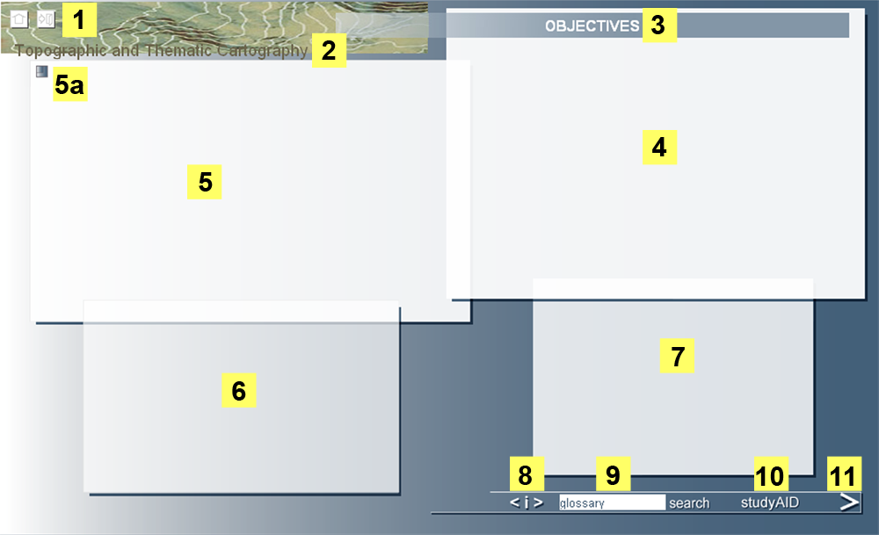
Figure 1: Blank user interface of NAHRIS (see text for details on numbered items).

A link to return to the overview and logout functionality is on the upper left of the browser window (1). Unit (2) and page title (3) are on top of the four-window structure of the main content windows (4, 5, 6, and 7) where possible resize links are integrated (5a). A shortcut navigation panel (8) allows for jumping to pages within the unit directly. A glossary can be retrieved (9), as can a text file be downloaded (10) at any time during the course session. A forward link brings the user to the next page (11).

Structuring the cartographic content
Conceptual cartographic contents are presented in the topic group Data Presentation of Module 1. The following nine learning units are introduced:

- data presentation and visualization  - definition of recipients and users of map  - topographic and thematic cartography  - standardization and classification | - color schemes  - quantitative data representation  - instruments for digital cartography  - uniform guidelines for phenomena maps
- symbolization of spatial information for thematic maps

Bringing exploratory techniques to the user
Apart from text-based content that intends to elaborate on theories and underline certain concepts to the students in a descriptive way, numerous illustrations (maps, photographs, graphics, etc.) were used to design the course as varied as possible. For example, easy-to use slide shows are an integral part of many of the pages. However, where deemed appropriate (i.e., where it was supposed to bring a pedagogical surplus), exploratory examples were developed and integrated into the four-window structure. Computer-based visualization tools have additional properties (compared to paper maps): interactivity and dynamics. Exploratory techniques that apply to these properties are querying and map animation (ANDRIENKO et al. 2003).
Most of the exploratory examples in NAHRIS offer queries for looking up data, although examples when data are filtered are also provided. Basically, examples are released by the most established intrinsic events, e.g. onClick, OnMouseOver and onLoad (W3C 2006) to which a certain script handler is associated. In order to provide truly “hands-on” training, queries are performed either by direct manipulation of graphical elements on the screen or by integrated buttons. Thereby, the position of the mouse cursor determines the constraints of the query (i.e., by the coordinates of the location) and the result is a highlighted object along with corresponding attribute values in a target area on the display.
Exploratory examples making use of map animation are less numerous in NAHRIS. They are employed where temporal changes have to be appropriately pointed out and where they evidently contribute to more understanding about the underlying spatial pattern. Offering animated interactive tools in teaching cartography is not a technical but rather an educational challenge. Limitations are set by human creativity and students’ expectations which they have from interactive, non-educational products such as computer games (JONES et al. 2004).

Embedding cartographic tools into NAHRIS
The content of each learning unit was first storyboarded on external text documents and peer reviewed by module leaders. The implementation of these storyboards took place using a JavaScript template that consisted of three main components: a global library controlling the display properties of the user interface, a root file containing information about the learning unit’s title and subtitles and an input template file (on which we narrow the details in the following).
The template is a JavaScript file that stores learning unit content (discussed below) and its formatting parameters in a three-dimensional array. Among these parameters are unique identifiers in order to address any of the content windows and their instances respectively. The template also contains content visibility, aligning and font style attributes which are passed to, and used by, cascade style sheets. In addition, window enlargement functionality can be passed as arguments to functions provided by the global library.
The content is inserted into the template file using hypertext markup language (HTML). Yet, the template allows for the inclusion of additional, encapsulated web-techniques such as the commercial Adobe Flash software or freely available scalable vector graphics language. Common to both vector-based techniques are their capabilities to scale graphical contents according to a given bounding box. As to the user interface shown in Figure 2, this is particularly beneficial when content windows are being resized since the visual quality of the content remains virtually unchanged. Another shared feature of Flash and SVG is the possibility for creating convincing animations and interactive control panels. Both techniques were numerously applied, even for implementing other NAHRIS modules.

Results – Illustrative examples

Preliminary notes
In the following, we take up some of the contents of Module 1 that exemplify our attempt to bring the basics of cartography into an e-learning environment dealing with natural hazard and risk management. Needless to say, merely a few examples are discussed.

Slide shows for comparisons
One type of a slide show is shown in Figure 2. The relevant object (in this case a polar diagram of temperature) is usually placed centrally in the display area (1). A button (1a) can be clicked to have the content enlarged and more apparent, as is the case in the figure. Forward and backward buttons encapsulated in the slide show are provided (2) along with descriptive text of which some parts are linked to the diagram. When the user moves over a term (3), the item is highlighted in the diagram. Another technique applied for slide shows involves fading out of one representation into another using a blank background image that changes its transparency.

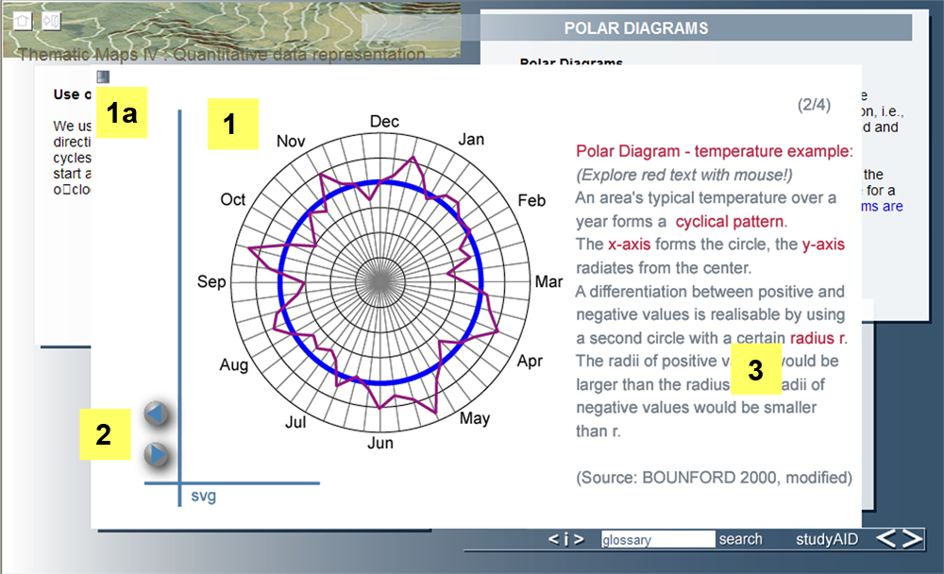
Figure 2: Slide show to illustrate the use of polar diagrams.

Animations for spatio-temporal processes
Each of the animations included in the module has at least buttons to start, pause and stop (i.e., reset) it. The example shown in Figure 3, however, expands these functionalities. It shows the dynamic processes of a Swiss glacier using blue or red circles that indicate the amount of increase or decrease of the glaciers elevation for a specific 50x50 m grid.

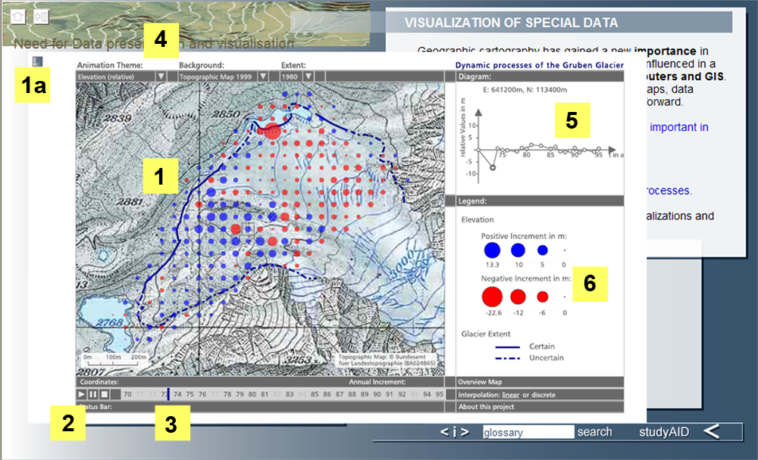
Figure 3: Animation of a glacier’s processes between 1970-1995.

The display area (1) is resized by a link (1a). In addition to the basic controls of start, stop and pause (2) there is a time bar (3) that simultaneously progresses with the changes on the map, thus conveying more pronounced the temporal aspect. A range of interactive options lets the user choose an animation theme (either absolute or relative elevation, areal extent or surface velocity), a background map (a topographic map for example as shown in the figure), the areal extent for a chosen year or a timeframe during which the animation plays. A diagram window (5) shows the temporal evolution of the chosen animation theme in form of a graph and the legend (6) further helps to understand the animation. Other animations used in the module are plain as to their user interaction (merely play, pause, stop buttons are provided). They are more complex however, in that they are 3-D or fly-by.

Self-evaluation tests
After each learning module, the user is requested to complete a self evaluation test. It’s particularly these tests that offer the most interaction for the user, including clicking multiple-choice boxes, filling in forms with text, and moving elements by “drag-and-drop” techniques. This way, visual examples are created on the fly and users instantly get to see how different considerations during the map-making process affect the appearance and readability of a map.

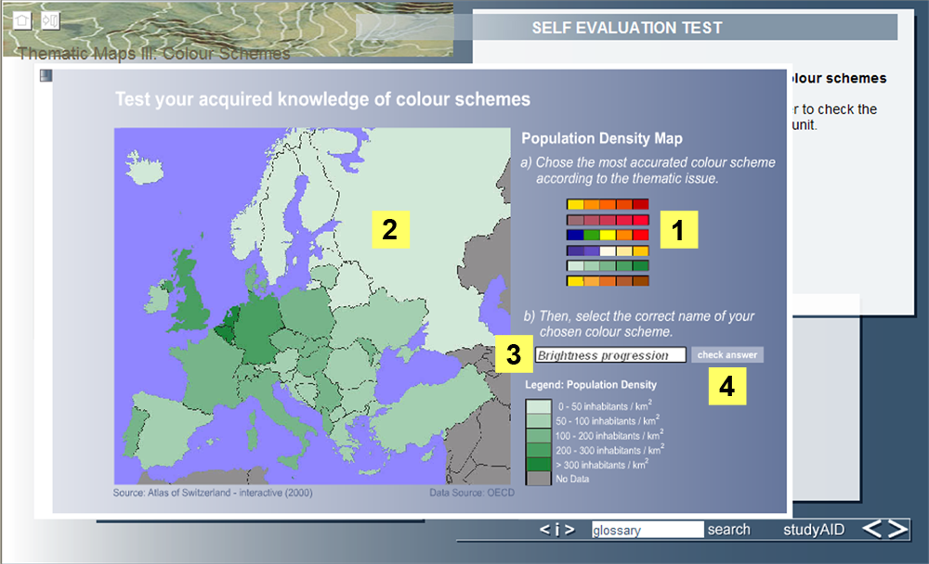
Figure 4: Self-evaluation test for the topic “color schemes”

The example of a self evaluation test of the topic “color schemes” given in Figure 4 initially shows an uncolored map. The user can pick from a range of color schemes such as bipolar progression or unordered hue progression (1) and drop them onto the map. The chosen scheme is instantly visualized (2) along with a legend as is any other, subsequent choice. To confirm, the user is requested to name the chosen scheme (3) and check the answer by clicking on a button (4) that returns a validation in form of a short note.

Other multi-media elements
In Module 1 (as well as in other Modules of NAHRIS), movies and audio have been embedded to additionally support the user in her or his learning process. The types vary from self-made animation-like movies to movies that have been recorded from TV broadcasts.

Conclusion and Outlook
The e-learning project NAHRIS has been designed to facilitate online education and training in the field of Natural Hazards. A user interface uses four windows to integrate text, images and multimedia within an authoring framework. Thanks to this framework, the dissemination of cartographic concepts and tools for the natural hazard and risk management domain proved to be practicable. Stand-alone cartographic content, enriched by interactivity and dynamic visualizations, could be well integrated into the e-learning environment using vector-based applications. However, one unsettled point that regards the whole of NAHRIS remains the inconsistent appearance of some multi-media content, mainly unwanted deformations. Fortunately, these are not apparent in the most established browsers and operating systems.
While cartographic theories or natural hazard research have quite numerously found their way into e-learning projects, the combination of cartography with natural hazard education remains a rare case. Given that access is freely available on www.nahris.ch, it is not surprising that NAHRIS enjoys a growing popularity among cartographers, geographers, engineers and other natural hazard scientist from all over the world.

References

